UWP Public Newsletter  Employee/Agency Spotlight Submission Form | 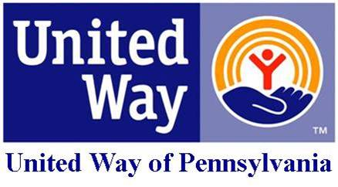

- Name of Employee or Agency.
- Contact Information for Employee (email) or Agency
- Describe how this Employee or Agency carries out the mission of United Way.
- Is there any other information you would like to share about your Employee/Agency?

Please submit form to:
Maggie Livelsberger, Public Policy and Communications Associate
Email: Maggie@uwp.org
Phone: 717-238-7365 ext. 203

