Preparer App Test Cases
Summary
Provided below are key use cases for the Tax Preparer Scheduling App. Site Administrators should be comfortable that these use cases meet their sites’ needs for the coming tax scheduling season. These use cases are:
- One-Time Site Setup
- Add Preparers
- Set Preparer Availability
- Schedule Appointments
- Edit Appointments
- Communicate with Users
- Activity Reports
- User Roles and Capabilities
As you review, make note of anything that might not work for your site. When providing feedback, please describe the level of inconvenience any observations will cause, to help us prioritize any changes. Please note that these screens may change in small part, based on improvements for the coming tax season.

Use Case Descriptions and Instructions
- One-Time Site Setup
On the left-hand pane, see options ‘Site List’ and ‘Add Site’ under the ‘Site’ section.
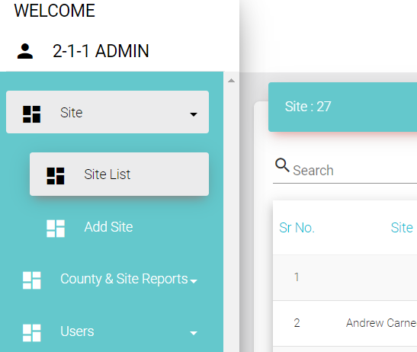

Choose ‘Add Site’ and fill in all site information, including special capabilities and break times.
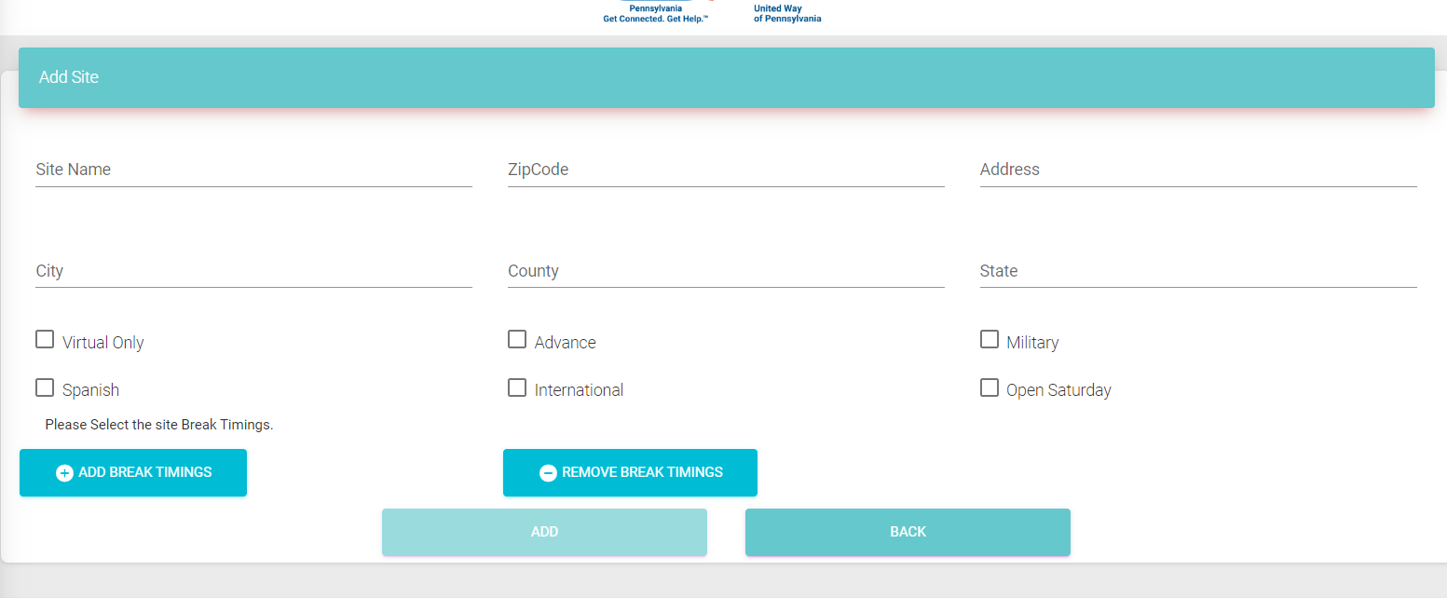

View and edit your site in the ‘Site List’.
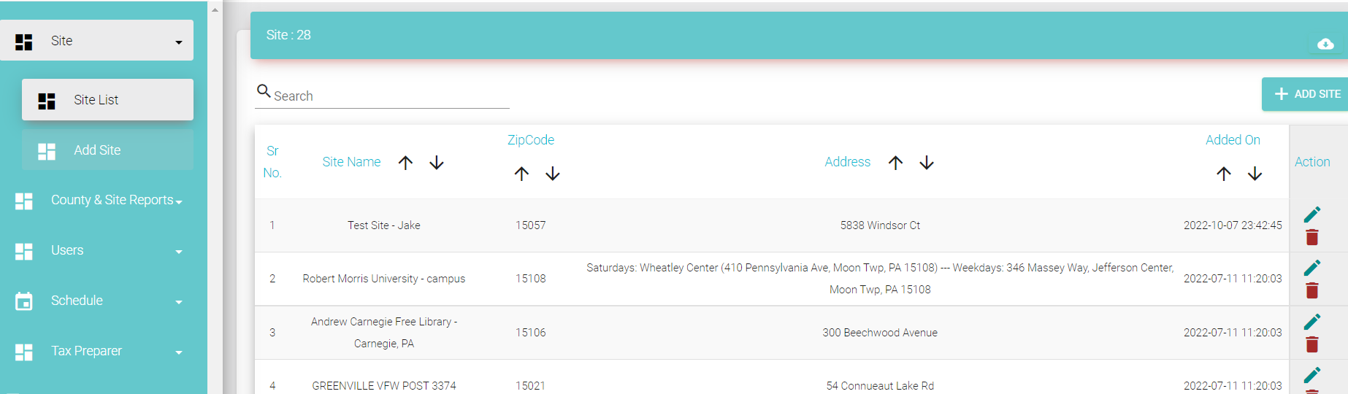

- Add Preparers and Users
On the left hand panel, choose ‘Add Preparer’ under the ‘Tax Preparer’ section
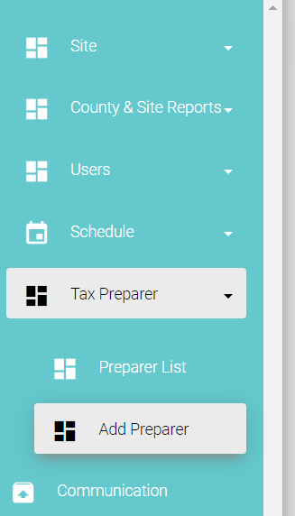

Enter Preparer personal, Site and special skill information.
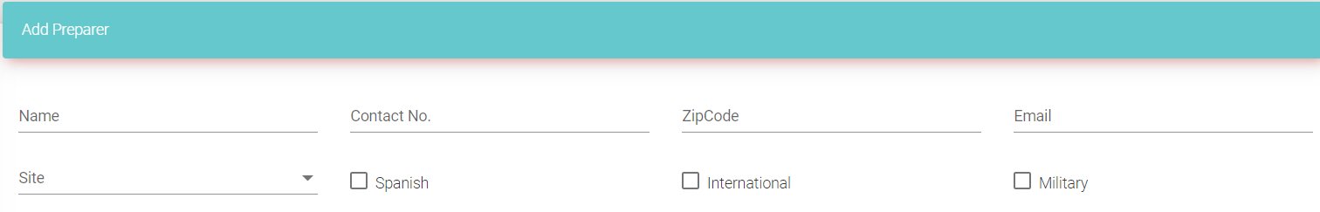
Define the lengths of various appointment types for that preparer, and submit for approval. Note: For the coming tax season, each appointment will have a standard length for all preparers, with ‘add on’ lengths for ‘Interpretation’ and ‘Multi-Year’
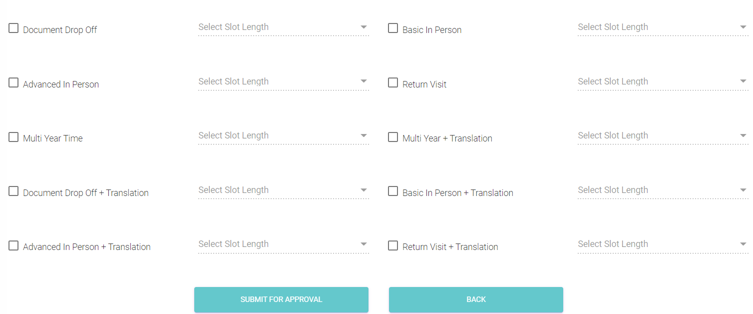

- Set Preparer Availability
You will be taken to ‘Preparer List’, where you can click on the Calendar icon to set the preparer’s availability.
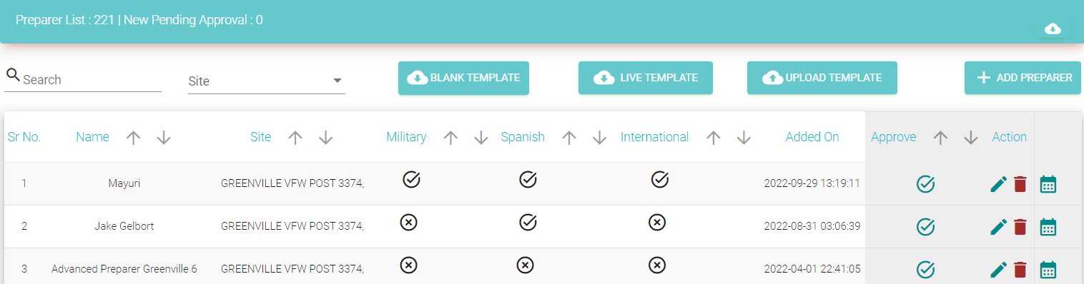

Add the Preparer’s availability by setting a Start Date and an End Date, then the hours available on specified days of the week. Multiple availability timeframes can be created for a preparer by clicking the ‘+’ button in the lower left corner or removed with the ‘trash can’ icon. Overlapping availability windows will be additive.
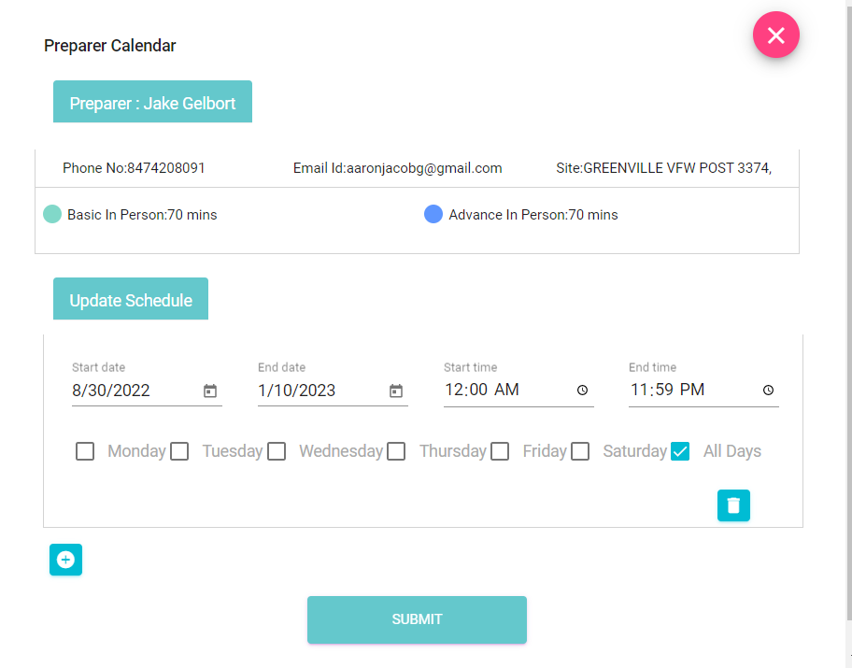

- Schedule Appointment
On the left-hand panel, choose ‘Schedule Appointment’ under the ‘Schedule’ section
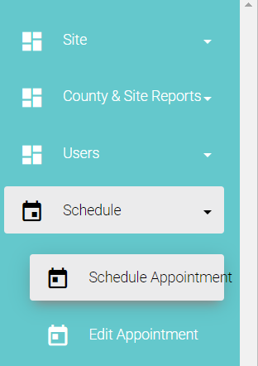

If schedulers need to confirm the individual’s eligibility for the program, they can choose ‘Check Eligibility’, which guides takes them through a set of questions to determine available sites and appointment type.
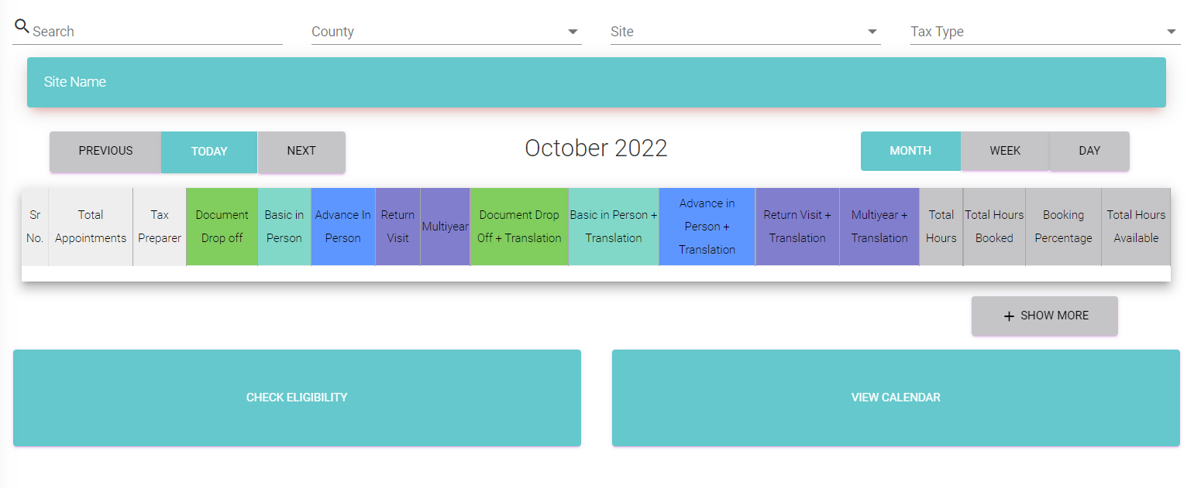
To find an open appointment slot, select the County, Site and Tax Type, then click ‘View Calendar’.
A calendar will show up below, with existing numbers of appointments shown by day. Click the day on which you would like to schedule the appointment.
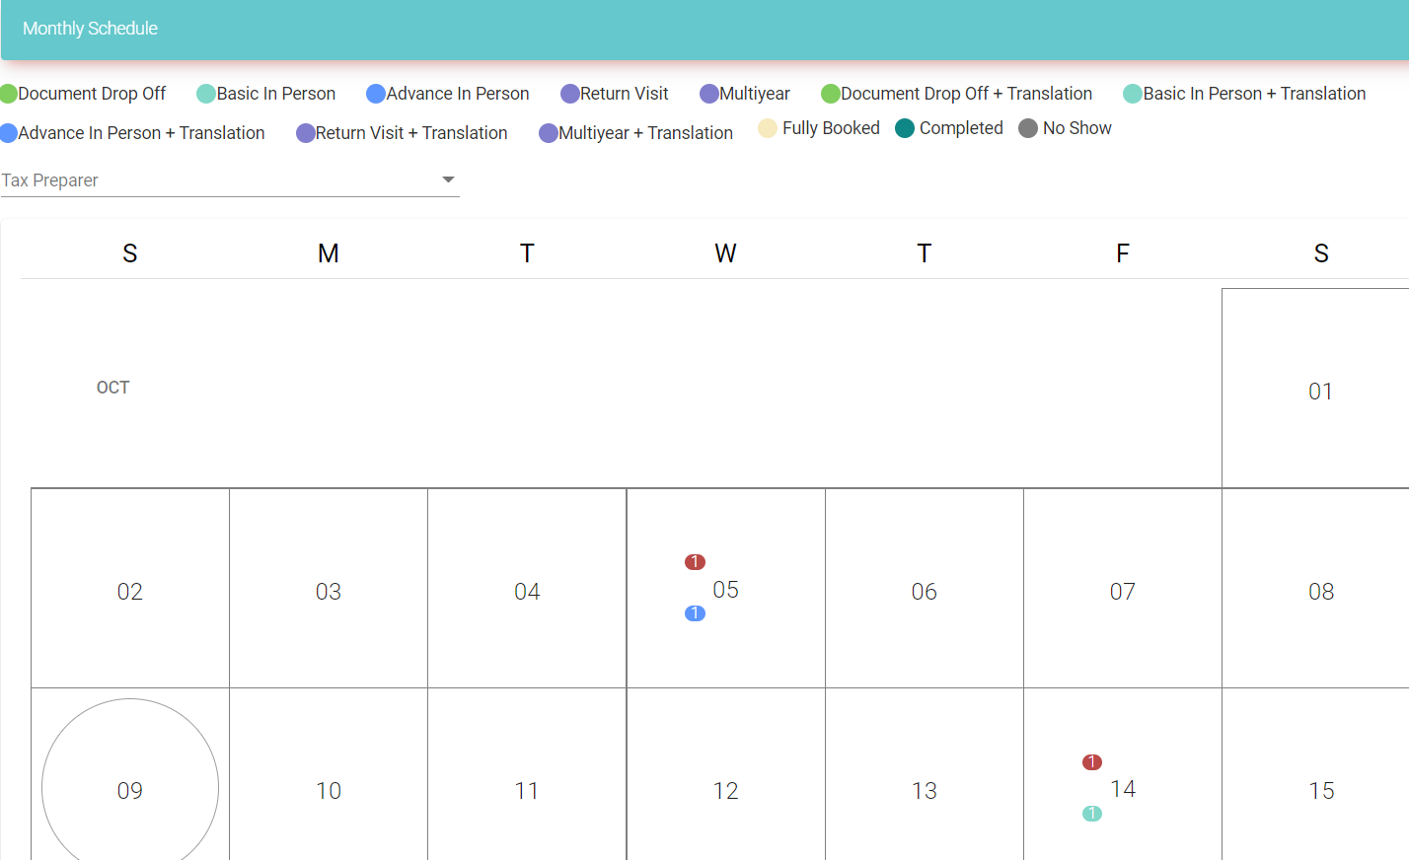

The month calendar will change into a day calendar, in which you can choose various time slots. Click the 15 minute interval in which you would like the appointment to start, to begin scheduling.
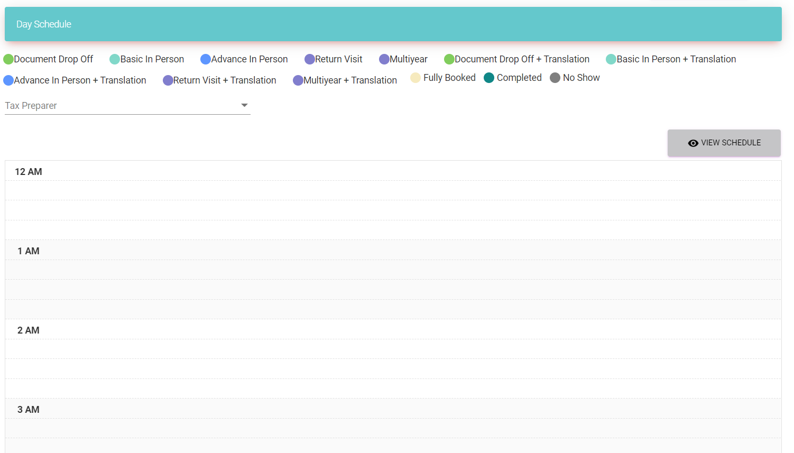

A screen will pop up, in which you can fill the individual’s personal information and appointment details. The appointment time can be modified here as well. Click ‘Schedule Appointment’ once complete.
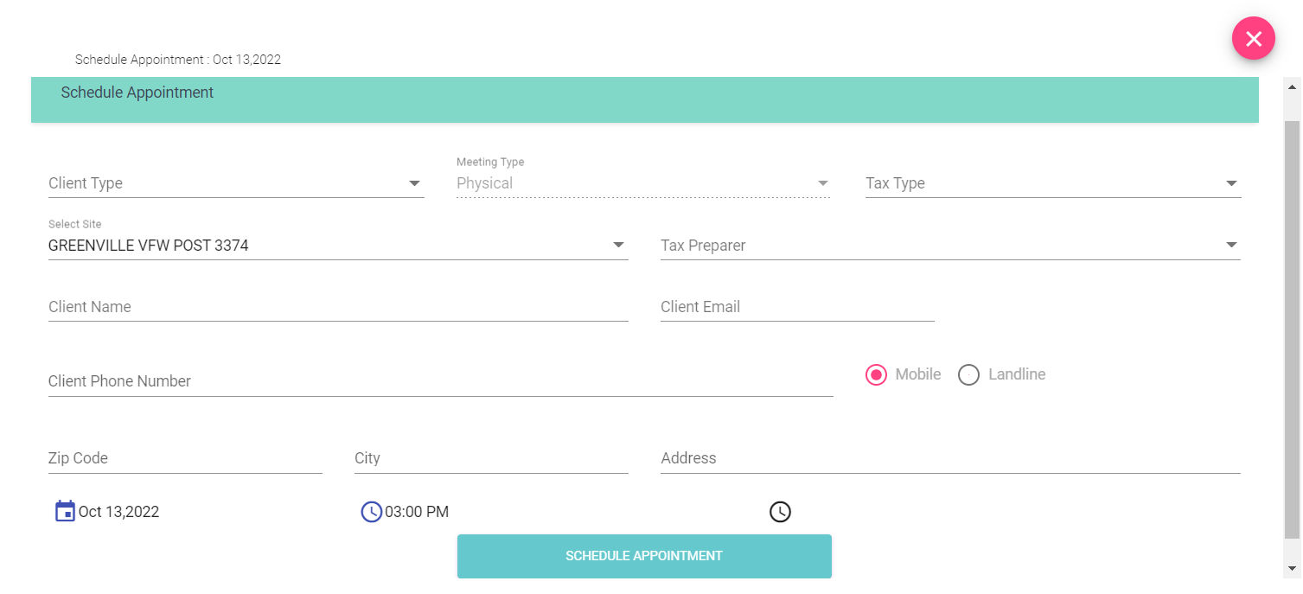
The appointment is added to the day calendar, where you will be taken.
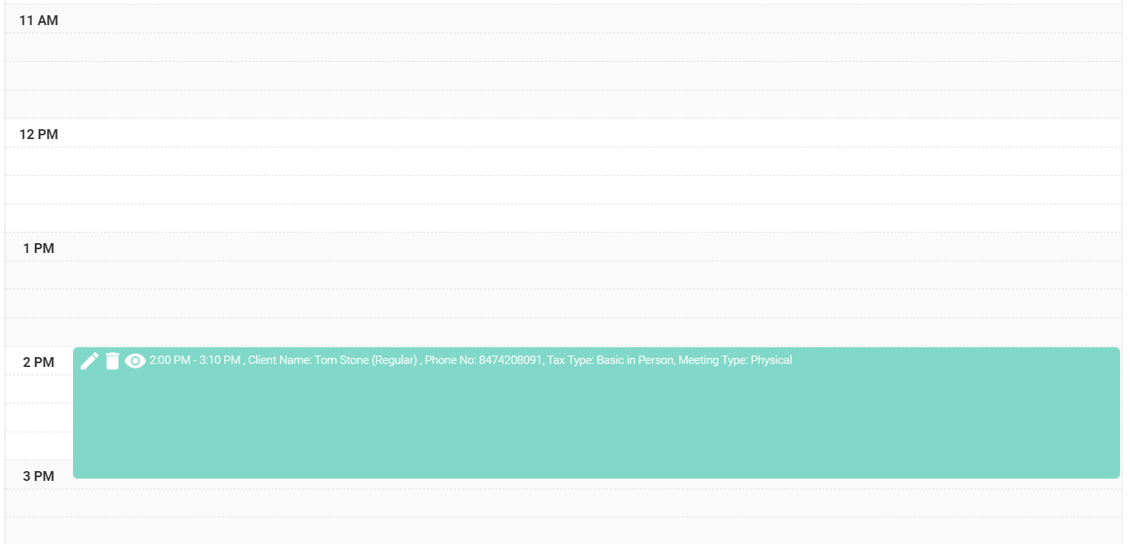
- Edit Appointment
Once an appointment is created, it can immediately be edited using the ‘Pencil’ icon, or deleted using the ‘Trash Can’ icon.
The preparer can also log the outcome of the appointment by clicking the ‘Eye’ icon in the day calendar veiw. They can use the picklist to convey what happened. Note: For the coming tax season, options will be changed to ‘Completed’, ‘No Show’, ‘Out of Scope’ and ‘Canceled’.
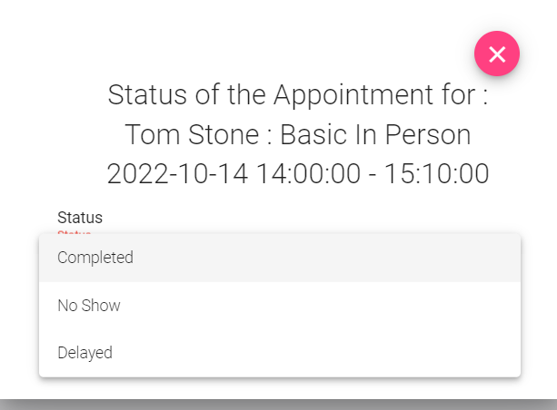
Once a user has moved off the Day Schedule page, existing appointments can be found in several ways. Users can go back to ‘Schedule Appointment’ and click ‘View Calendar again to search by day. They can also go to the ‘Edit Appointment’ tab on the left-hand pane. This allows them to search appointments by email address or phone #.
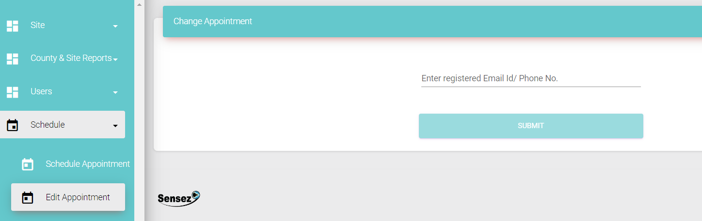

- Communication with Users
Upon creating an appointment, a confirmation is sent to the individual via text message and email. The message contains a link to more detailed instructions about the appointment. Note: An email will also be sent to the user, with similar details to the below.
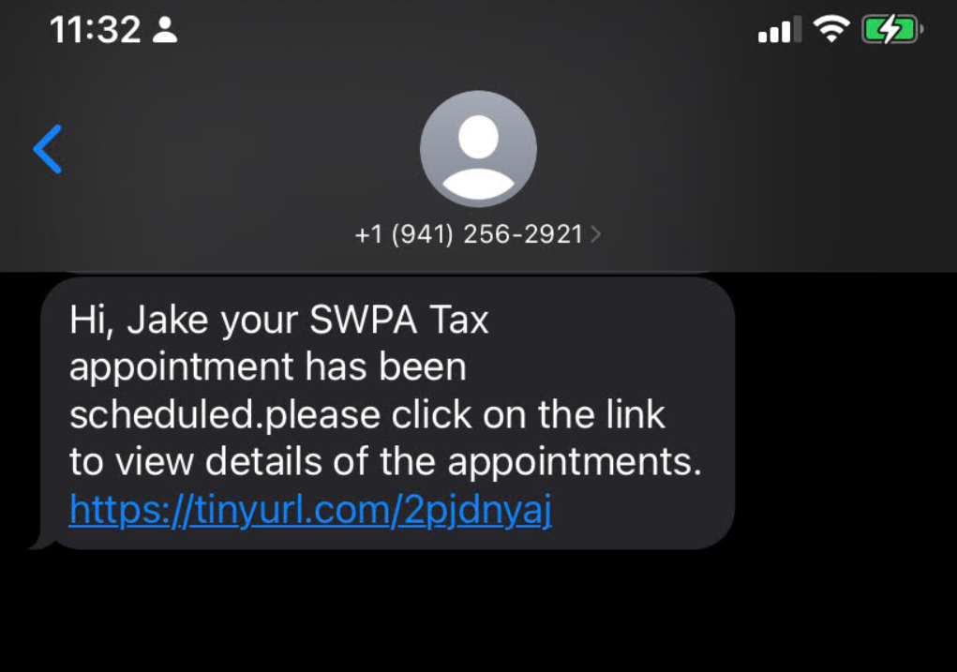
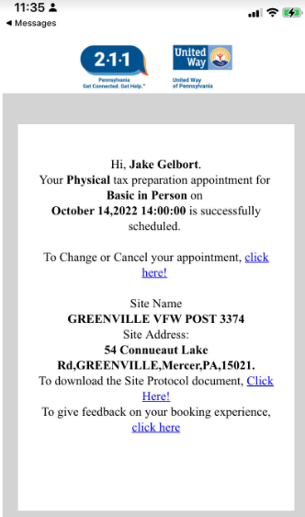
- Activity Reports
Details of contacts and appointments will be provided to site administrators in CSV files
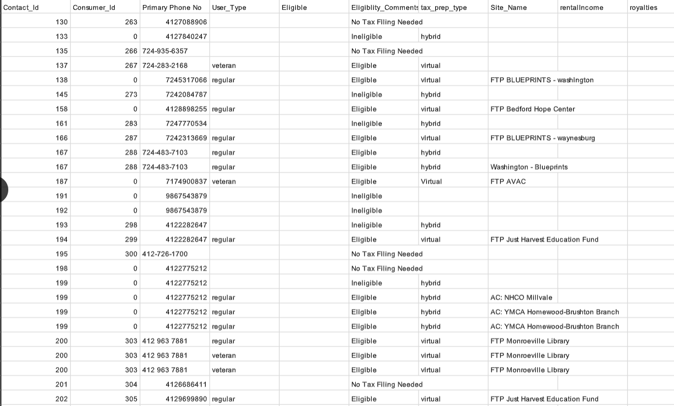
Overall reports about quantity of appointments, by type, date, outcome, etc. can be viewed in the ‘Graphs & Statistics’ tab under the ‘County & Site Reports’ dropdown in the left-hand pane.
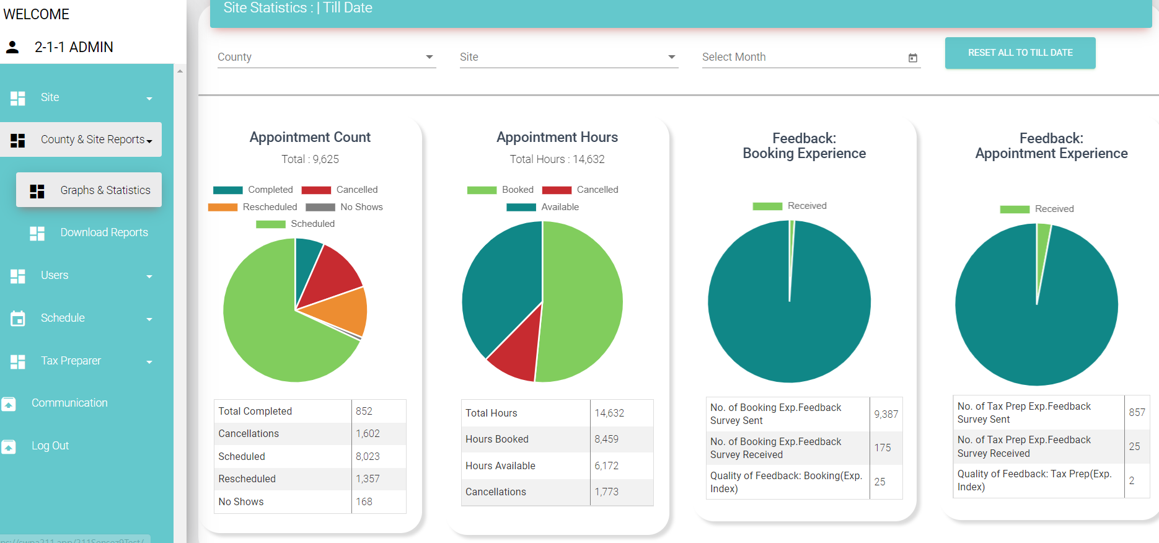
Data on overall appointments can also be downloaded to Excel in the ‘Download Reports’ tab in the left-hand pane.
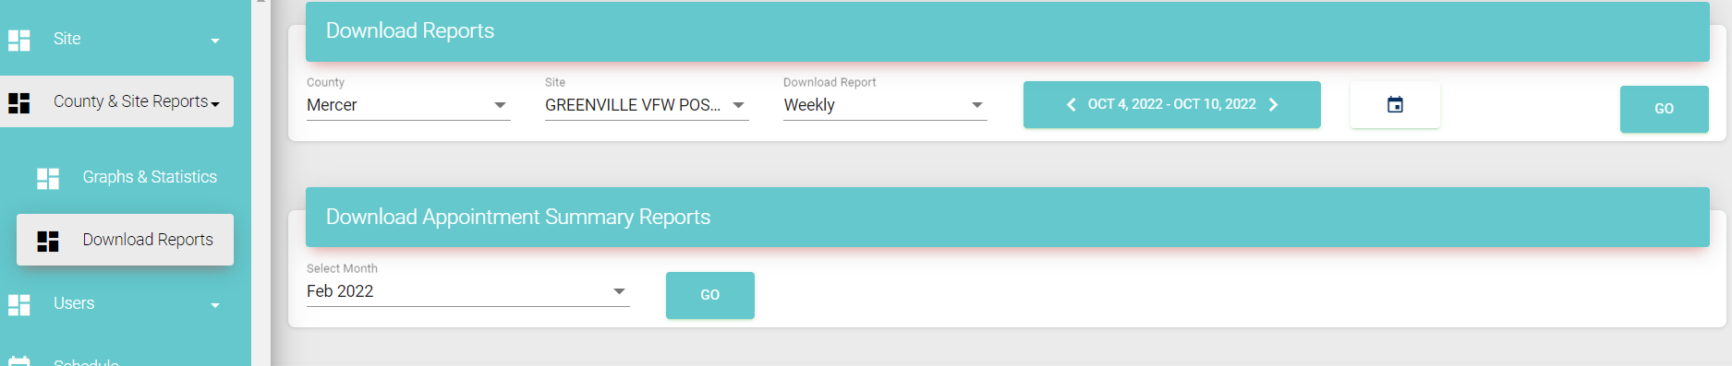

- User Roles and Capabilities
Permissions within the app are governed by User Roles, set when adding users. There are six User Roles, with permissions decreasing from top to bottom:
- Client Super Admin
- Region Super Admin
- County Coordinator
- Site Coordinator
- Site Assistant
- Resource Navigator
Roles matter for three areas: Setup and Configuration and Creating Bookings and Managing Cancellations.
- Setup and Configuration
For Setup and Configuration, Roles determine who can create Sites, Users, Preparers and Schedules. Resource Navigators have no role in setup, and cannot create anything. Any role above Resource Navigator can create Preparer Schedules. Resource Navigators and Site Assistants cannot create Preparers, but any Role above them can. Any role County Coordinator and above can create Users and Sites. See below for a graphic summary of this information:
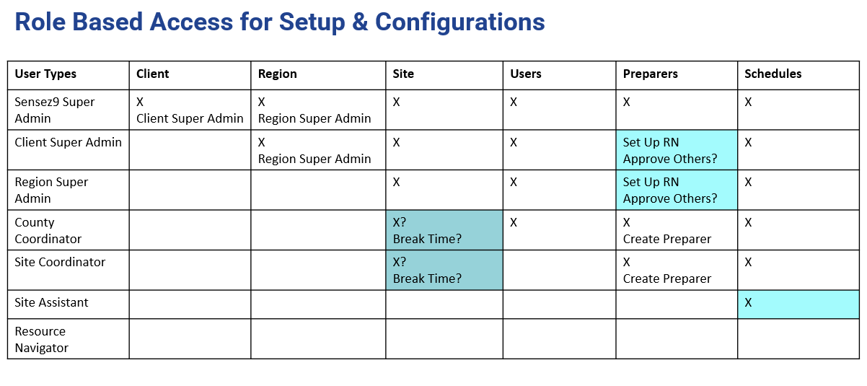
- Site Selection for Bookings and Cancellations
Roles determine which Site, County and Region options are available when booking appointments. Resource Navigators must select their County and Site each time Site Coordinators and Site Assistants will have their County and Site automatically selected for them, so that they can only see their own site. County Coordinators have their County selected for them, but can choose any site in that County. Region Super Admin has their Region automatically selected, but can choose any County or Site in that region. Client Super Admin will have to choose Region, County and Site. These selections are summarized below:
